Lab-6
🔹 Basic Template Assignments
Function Template – Swap
Write a function template swapValues() that swaps two variables of any type.

Test with int, double, and string.

Function Template – Maximum
Write a function template findMax() that returns the maximum of two values.

Test with int, float, and char.
3: Class Template – Box
Implement a class template Box<T> that stores one value of any type and provides getValue() and setValue() methods.

Class Template – Calculator
Create a class template Calculator<T> with functions:

add(), subtract(), multiply(), divide().
Test with int and double.

#include <iostream>
using namespace std;

template <class T>
class Calculator {
private:
T num1, num2, result;
public:
Calculator(T num1, T num2) {
this->num1 = num1;
this->num2 = num2;
}
void add() {
result = num1 + num2;
cout << "Result is = " << result << endl;
}
void sub() {
result = num1 - num2;
cout << "Result is = " << result << endl;
}
void mul() {
result = num1 * num2;
cout << "Result is = " << result << endl;
}
void div() {
if (num2 == 0) {
cout << "Division by zero error!" << endl;
} else {
result = num1 / num2;
cout << "Result is = " << result << endl;
}
}
};

int main() {

int ch;
do{
cout << "Enter your choice : \n1.addition\n2.subtraction\n3.multiplication\n4.division\n5.exit" << endl;
cin >> ch;

if (ch >= 1 && ch <= 4) {
cout << "Choose data type:\n1. int\n2. double" << endl;
int dtype;
cin >> dtype;

if (dtype == 1) {
int a, b;
cout << "Enter two numbers: " << endl;
cin >> a >> b;
Calculator calc(a, b);
switch (ch) {
case 1: calc.add(); break;
case 2: calc.sub(); break;
case 3: calc.mul(); break;
case 4: calc.div(); break;
}
} else if (dtype == 2) {
double a, b;
cout << "Enter two numbers: " << endl;
cin >> a >> b;
Calculator calc(a, b);
switch (ch) {
case 1: calc.add(); break;
case 2: calc.sub(); break;
case 3: calc.mul(); break;
case 4: calc.div(); break;
}
} else {
cout << "Invalid data type choice." << endl;
}
} else if (ch == 5) {
cout << "Exit" << endl;
} else {
cout << "Invalid choice." << endl;
}
}while(ch!=5);
return 0;
}

Output:
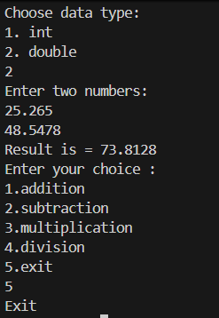

Function Template – Array Sum
Write a function template sumArray() that accepts an array of any type and returns the sum of its elements.

#include<iostream>
using namespace std;

template<class T>
void sumArray(T arr[], int size){
T sum = 0;
for(int i=0;i<size;i++){
sum = sum + arr[i];
}
cout<<"Sum = "<<sum<<endl;
}

int main(){
int size = 5;
int arr1[] = {1,2,3,4,5};

double arr2[] = {1.1,1.1,1.1,1.1,1.1};
sumArray(arr1,size);
sumArray(arr2, size);
}

Output:
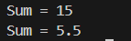

6: Class Template – Stack
Implement a class template Stack<T> with functions: push(), pop(), peek(), isEmpty(). Test with int and string.

#include<iostream>
#include<string>
using namespace std;

template <class T>
class Stack {
private:
int top;
T arr[10];
public:
Stack() {
top = -1;
}
void push(T val) {
if (top >= 9) {
cout << "Stack overflow" << endl;
} else {
top = top + 1;
arr[top] = val;
cout << val << " is added in stack." << endl;
}
}

void pop() {
if (top == -1) {
cout << "Stack underflow" << endl;
} else {
cout << arr[top] << " is popped out from stack" << endl;
top--;
}
}

T peek() {
if (isEmpty()) {
cout << "Stack is empty" << endl;
return T();
}
cout << "Topmost element of stack = " << arr[top] << endl;
return arr[top];
}

bool isEmpty() {
return (top == -1);
}

// void display() {
// if (isEmpty()) {
// cout << "Stack is empty" << endl;
// return;
// }
// cout << "Stack elements:" << endl;
// for (int i = top; i >= 0; i--) {
// cout << "[" << arr[i] << "]" << endl;
// }
// }
};

int main() {
Stack<int> mystack;
int ch;
do {
cout << "\n1.Push\n2.Pop\n3.Peek\n4.IsEmpty\n5.Display\n6.Exit\n";
cout << "Enter your choice:" << endl;
cin >> ch;
switch (ch) {
case 1: {
int val;
cout << "Enter element to push: ";
cin >> val;
mystack.push(val);
break;
}
case 2:
mystack.pop();
break;
case 3:
mystack.peek();
break;
case 4:
if (mystack.isEmpty())
cout << "Stack is empty" << endl;
else
cout << "Stack is not empty" << endl;
break;
// case 5:
// mystack.display();
// break;
case 6:
cout << "Exit" << endl;
break;
default:
cout << "Invalid choice" << endl;
}
} while (ch != 6);

return 0;
}

Output:
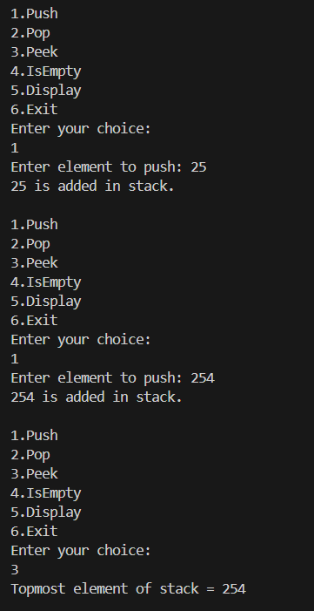

//Function Template � Swap
// Write a function template swapValues() that swaps two variables of any type.
#include<iostream>
using namespace std;

template <class A>
void swapValue(A& a, A& b){
A temp;
temp = a;
a = b;
b = temp;
}

int main(){
// int a, b;
char a,b;
cout<<"Enter two numnber a , b :"<<endl;
cin>>a>>b;
swapValue(a,b);
cout<<"a = "<<a<<" b = "<<b<<endl;
}

Output:
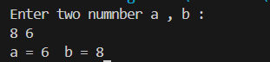

//Function Template � Maximum
// Write a function template findMax() that returns the maximum of two values.

#include<iostream>
using namespace std;

template<class Q>
void findMax(Q &num1,Q &num2)
{
if(num1>num2){
cout<<"number 1 is greater "<<num1<<endl;
}else{
cout<<"number 2 is greater "<<num2<<endl;
}

}
int main(){
//int a,b;
char a,b;
cout<<"enter two numbers for finding max: "<<endl;
cin>>a>>b;

findMax(a,b);
}

Output:
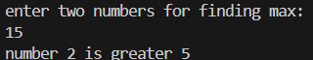

//3: Class Template � Box
// Implement a class template Box<T> that stores one value of any type and provides getValue() and setValue() methods.

#include<iostream>
#include<typeinfo>
using namespace std;

template<class T>
class Box{
private:T val;

public:
Box(T val){
this->val = val;
}
void display(){
cout<<endl<<val<<endl;
}
T getValue(){
return val;
}

void setValue(T newval){
this->val = newval;
}
};
int main(){
//for int
Box <int>b1(30);
b1.getValue();
b1.display();
int a;
cout<<"enter a number to change: "<<endl;
cin>>a;
Box <int>b2(a);
b2.display();

//for char
Box < char>b1('a');
b1.getValue();
b1.display();
char a;
cout<<"enter a number to change: "<<endl;
cin>>a;
Box < char>b2(a);
b2.display();
}

Output: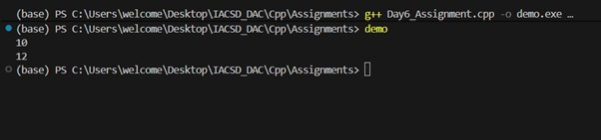

4. Queue implementation using template

#include<iostream>
using namespace std;

template<class T>
class Queue
{
private: T front,rare;
T arr[10];
public : Queue()
{
this->front = -1;
this->rare = -1;
}
void enqueue(T value)
{
if(rare>=9)
{
cout<<"Queue Overflow"<<endl;
}
else
{
if(front==-1)
front++;
rare++;
arr[rare]=value;

}
}
void dequeue()
{
if(rare<0)
{
cout<<"Queue UnderFlow"<<endl;
}
else
{
cout<<"Dequeued element: "<<arr[front]<<endl;
front++;

if(front>rare)
{
front=rare=-1;
}
}
}
void isFront()
{
cout<<"front value is: "<<arr[front]<<endl;
}
void isEmpty()
{
if(front == -1)
{
cout<<"true"<<endl;
}
else
{
cout<<"false"<<endl;
}
}
};
int main()
{
Queue <int>q;
q.enqueue(10);
q.enqueue(20);
q.isFront();
q.dequeue();
q.isEmpty();
return 0;
}

Output:
